Kindergarten Student Activities
Here are some fun and engaging activities designed for kindergarten students to help them learn, play, and grow in a creative environment.
1. Story Time | Reading colorful picture books aloud to children and asking simple questions to encourage imagination and listening skills. 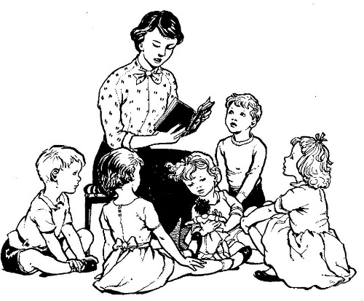
2. Arts and Crafts | Using paper, crayons, glue, and scissors to create simple crafts like animals, flowers, or shapes to boost creativity and fine motor skills.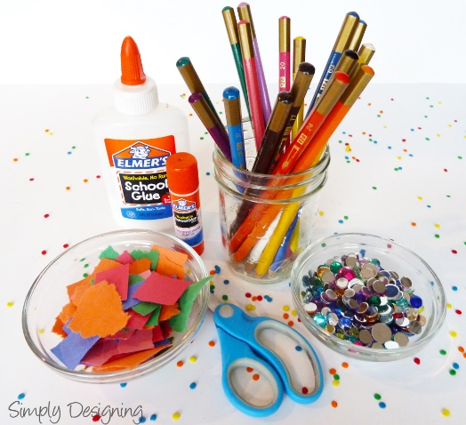
3. Sing-Along and Dance | Singing nursery rhymes and dancing to fun tunes to improve memory, rhythm, and coordination. 
4. Puzzle Play | Solving simple jigsaw puzzles or shape-matching games to develop problem-solving and thinking skills. 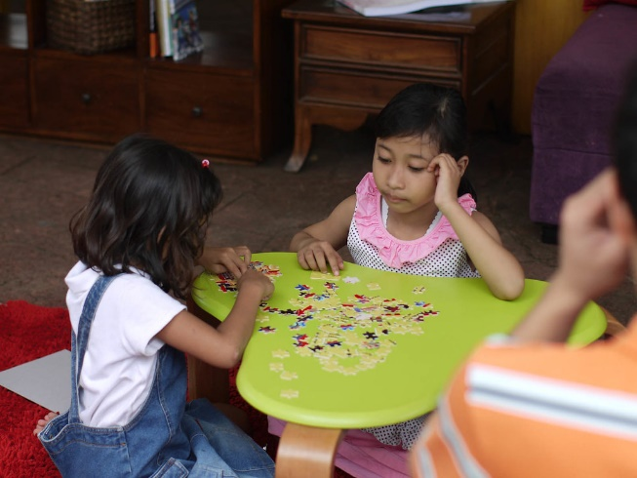
5. Outdoor Play | Engaging in activities like running, ball games, or hopscotch to encourage physical development and teamwork. 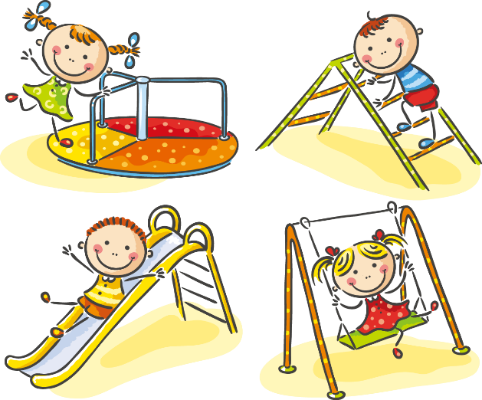
6. Counting and Sorting Games | Using blocks, beads, or toys to count, sort by color/size, and recognize patterns for basic math skills.